**Chapter 1: System Introduction**

# **Introduction**

Employee Management system is an application that enables users to create and store Employee Records. The application also provides facilities of a payroll system which enables user to generate Pay slips too. This application is helpful to department of the organization which maintains data of employees related to an organization. Java is a platform independent language. Its created applications can be used on a standalone machine as well as on distributed network. More over applications developed in java can be extended to Internet based applications. Thus java was chosen as background to design this application.

# **Objective of the Project**

In this world of growing technologies everything has been computerized. With large number of work opportunities, the Human workforce has increased. Thus there is a need of a system which can handle the data of such a large number of Employees in an organization. This project simplifies the task of maintain records because of its user friendly nature.

**Chapter 2: System Analysis**

**Software Requirement Specifications**

* 1. **Introduction**

The following subsections of Software Requirement Specifications Document should facilitate in providing the entire overview of the Information system “Employee Management System” under development. This document aims at defining the overall software requirements for your end users. Efforts have been made to define the requirements of the Information system exhaustively and accurately.

* + 1. **Purpose**

The main purpose of Software Requirement Specifications Document is to describe in a precise manner all the capabilities that will be provided by the Software Application “Employee Management System”. It also states the various constraints which the system will be abide to. This document further leads to clear vision of the software requirements, specifications and capabilities. These are to be exposed to the development, testing team and end users of the software.

* + 1. **Scope**

The future looks quite good for organizations but it has been true, it will be good for enhanced productivity fully utilizing the combined talent and skills of the entire workforce of an organization. EMS must today reinvent itself to cope with the demands of a global economy.

**Description:**

**System Features**

**Module Names**:

1. **Administrator**
2. Login
3. Create Employee
4. Update Employee Records
5. Delete Employee
6. Project Allotment
7. Update Project Allotment
8. Delete Project
9. View Employee Record
10. Pay Slip Generation
11. Reset password
12. Logout
13. **Employee**
14. Login
15. Set Attendance
16. View Payslip
17. View Project
18. Reset Password
19. Logout

1. **Administrator**
2. **Login**

In the admin table, we have two attributes UserId and Password wherein the admin can login. He can view and edit student as well as trainer profile. He can update,add modify etc. in student as well as trainer profile.

**Validity Checks**

1. Email id
2. Password

**Sequencing Information/Exception handling**

First admin will enter the email id and password. If in case of admin login, he gives wrong email ID then he gets an error page.

1. **Create Employee:**

Admin can create record of new employees recruited in the firm, i.e. he can add the employee in his organization.

1. **Update Employee Record:**

Admin can update the employee record by adding employee, deleting any employee record etc.

1. **Delete Employee:**

In this module admin can delete the record of that employee who leaves the firm.

1. **Project Allotment:**

In this module admin allot the project to their employees.

1. **Update Project Allotment:**

In this module admin update the projects allotted to his/her employee, in updating admin can add more new modules in the project, or he also can delete the modules that are not required in project.

1. **Delete Project:**

In this module admin can delete the record of that project that leaves the firm.

1. **View Employee Record**

This is a module which shows the updated list of the entire employee with in a firm.

1. **Pay Slip Generation:**

The payslip generation control goes to only admin. Only admin can generate their employees on the basis of no. of days employee have attended.

1. **Reset Password:**

Admin can reset the password of its account.

1. **logout**

In this module the first screen will open and other screen will closed

1. **Employee**

Employee plays an important role in any organization, here employee can set his/her attendance in which he can check how many days in a month He/she was present, check payslip, and reset the password of their account.

**Validity Checks**

1. Set Attendance.

2. View Payslip.

**Sequencing Information/Exception handling**

If employee try to enter previous day attendance its gives an error page.

1. **Set Attendance:**

Employee can set the attendance example if he/she is present in the organization he can set the present.

1. **Reset Password:**

Employee can reset the password of his/her account.

1. **Check Payslip:**

Employee can check the payslip of his/her salary.

1. **Logout**

In this module the first screen will open and other screen will closed.

**Chapter 3: System Design**

**System Design**

1. **Physical Design**

Physical design of Spiritual search engine will provide all the mandatory functions which should be beneficial for the organization. In this, we completed the technical blueprints for the system, based on the implementation platform. Physical design is the generation of tables, indexes, defaults and the checking of restraints.

**Block Diagram**

Block diagram is a diagram of a system, in which the principal parts or functions are represented by blocks connected by lines that show the relationships of the blocks.  They are heavily used in the engineering world in hardware design, electronic design, software design, and process flow diagrams.

The block diagram is typically used for a higher level, less detailed description aimed more understanding the overall concepts and less at understanding the details of implementation.

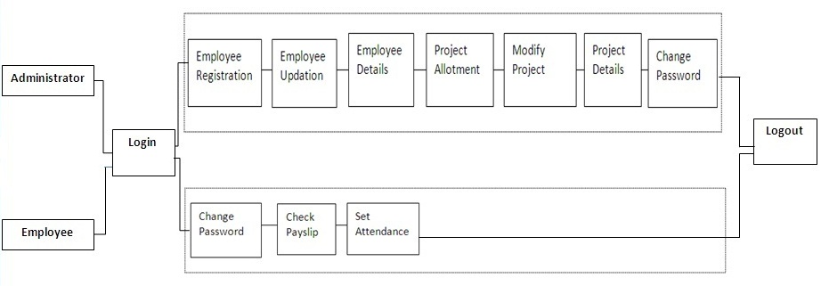

1. **Use Case**

USE-CASE diagrams are the pictorial representation of entities and their functions. There are two components of a use-case diagram – actors and use cases. It represents what happens when an actor interacts with a system. Hence, a use case diagram captures the functional aspects of a system. The system is shown as a rectangle with the name of the system (or subsystems) inside, the actors are shown as stick figures (even the non-human ones), the use cases are shown as solid bordered ovals labeled with the name of the use case, and relationships are lines or arrows between actors and use cases and/or between the use cases themselves. These components are given below:

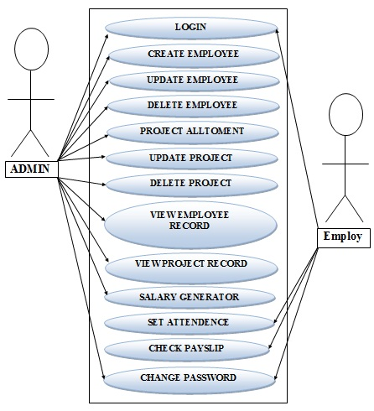

1. **DFD**

A DFD is a graphical representation that depicts information flow and the transforms that are applied as data moves from input to output. The basic form of a DFD is also known as a Data Flow graph or a Bubble Chart. DFD may be used to represent a system or software at any level of the transaction process. DFD’s can be partitioned into levels that represent increasing information flow and functional details.

**1). Level 0**

The next stage is to create the Level 1 Data Flow Diagram. This highlights the main functions carried out by the system. As a rule, we try to describe the system using between two and seven functions - two being a simple system and seven being a complicated system. This enables us to keep the model manageable on screen or paper.

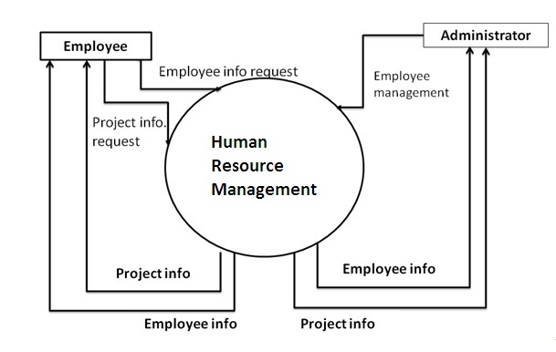

**2). Level 1**

Level Two DFD shows a detailed working of each module that is shown in the Level One DFD. These are as follows:

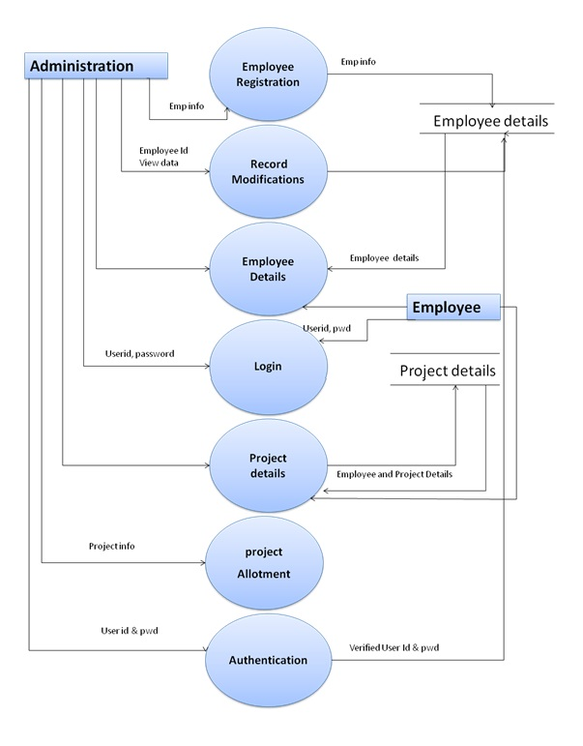

1. **ER Diagram**

An ER diagram depicts the relationship between data objects. The object-relationship pair can be represented graphically using the Entity-Relationship Diagram. A set of primary components is identified for the ER Diagram: Data Objects, attributes, relationships and various type of indicators. The primary purpose of an ER Diagram is to represent data objects and their relationships.

**Data Objects, Attributes and Relationships**

**Data Objects:** A data object is a representation of almost any composite information that must be understood by software. By composite information we mean something that has a number of different properties or attributes.

**Attributes:**They define the properties of a data object and take on one of the three different characteristics. They can be used to name an instance of the data object, describe the instances or make reference to another instance in another table.

**Relationship:** Data objects are connected to one another in a variety of different ways. We can define a set of objects-relationships pairs that define the relevant relationship. Object-relationship pairs are bi-directional. Different data objects and their attributes are described in the data dictionary and the relationship between these data objects are given in the ER diagram in the next section.

**Cardinality:**The data model must be capable of representing the number of occurrences of objects in a given relationship. The cardinalities of an object-relationship are:

**1). One to One (1:1)** – an occurrence of object ‘A’ can relate to one and only on occurrence of object ‘B’ and the occurrence of ‘B’ can relate to only one occurrence of ‘A’.

**2). One to Many (1:N)** – one occurrence of object ‘A’ can relate to one or many occurrences of object ‘B’ but an occurrence of ‘B’ can relate to only one occurrence of ‘B’.

**3). Many to Many (M:N)** – an occurrence of object ‘A’ can relate to one or more occurrences of ‘B’ while an occurrence of ‘B’ can relate to one or more occurrence of ‘A’.

Cardinality defines “the maximum number of object-relationships that can participate in a relationship”.

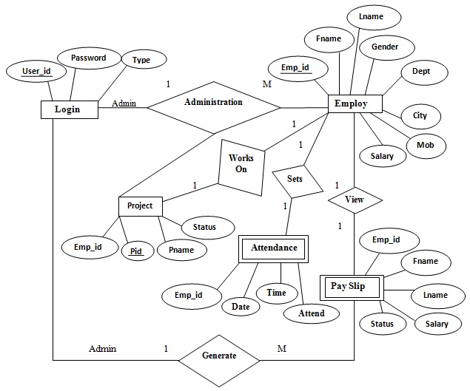

1. **Database Design**

The information system of “Employee Management System” performs its function with the help of the data store in certain repositories called Databases of the system. Detailed descriptions of the various databases included in the information systems are tabulated as follows:

**Login:**

|  |  |  |  |  |  |
| --- | --- | --- | --- | --- | --- |
| S.NO. | Field Name | Field Type | Field Size | Constraint | Description |
| 1. | UserId | Varchar | 20 | Primary | Enter the userid |
| 2. | Password | Varchar | 20 | - | Enter his password |
| 3. | Type | Varchar | 20 | - | Choose the User Type |

**Employ:**

|  |  |  |  |  |  |
| --- | --- | --- | --- | --- | --- |
| S.NO. | Field Name | Field Type | Field Size | Constraint | Description |
| 1. | Emp_id | Varchar | 20 | Primary | Enter The Employ Id. |
| 2. | Fname | Varchar | 20 | - | Enter The Employ First Name. |
| 3. | Lname | Varchar | 20 | - | Enter The Employ Last Name. |
| 4. | Gender | Varchar | 20 | - | Enter The Gender Male/Female |
| 5. | Dept | Varchar | 20 | - | Enter The Department. |
| 6. | City | Varchar | 20 | - | Enter The City. |
| 7. | Mob | Varchar | 20 | - | Enter The Mobile No. |
| 8. | Salary | Number | 20 | - | Enter The Salary. |

**Project:**

|  |  |  |  |  |  |
| --- | --- | --- | --- | --- | --- |
| S.NO. | Field Name | Field Type | Field Size | Constraint | Description |
| 1. | Emp_id | Varchar | 20 | - | Enter The Employ Id. |
| 2. | Pid | Number | 11 | Primary | Enter The Project Id. |
| 3. | Pname | Varchar | 20 | - | Enter The Project Name. |
| 4. | Status | Varchar | 20 | - | Enter The Project Status |

**Attendance:**

|  |  |  |  |  |  |
| --- | --- | --- | --- | --- | --- |
| S.NO. | Field Name | Field Type | Field Size | Constraint | Description |
| 1. | Emp_id | Number | 20 | - | Enter The Employ Id. |
| 2. | Date | Varchar | 20 | Primary | Enter The Date. |
| 3. | Time | Varchar | 20 | - | Enter The Time. |
| 4. | Attend | Varchar | 20 | - | Enter The Attendance. |

**Payslip:**

|  |  |  |  |  |  |
| --- | --- | --- | --- | --- | --- |
| S.NO. | Field Name | Field Type | Field Size | Constraint | Description |
| 1. | Emp_id | Varchar | 20 | Primary | Enter The Employ Id. |
| 2. | Fname | Varchar | 20 | - | Enter The Employ First Name. |
| 3. | Lname | Varchar | 20 | - | Enter The Employ Last Name. |
| 4. | Salary | Number | 20 | - | Enter The Salary. |
| 5. | Status | Varchar | 20 | - | Enter The Payslip Status. |

* **Interface Design**

The interface design consists of the input and output source layouts. i.e. the input forms and screens and the report layouts that form as a source of outcome and income in the design and implementation of the information system under study

1. **Input Design**

The input specifications of the existing information system include the illustration of the detailed characteristics of contents included in each Input Screen and documents. The description for each graphical user interface has been mentioned.

**EXISTING SYSTEM DESIGN (Graphical User Interface)**

**Main Form**

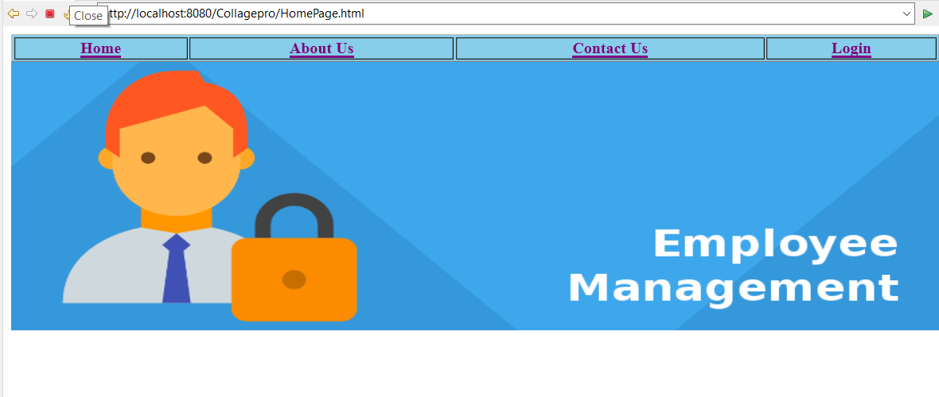

**Description**

This is the first page that should be first displayed in which we have two hyper references login and Contact.

**Admin/Employ login Form**

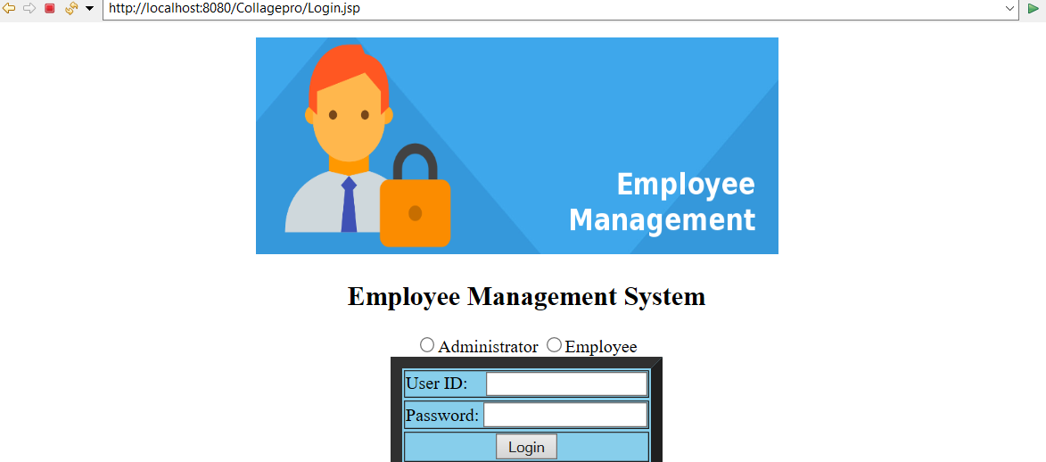

**Description**

This is the admin or employ login page in which admin or employ can easily login with two fields first one is email id and second one is password and choose the user type.

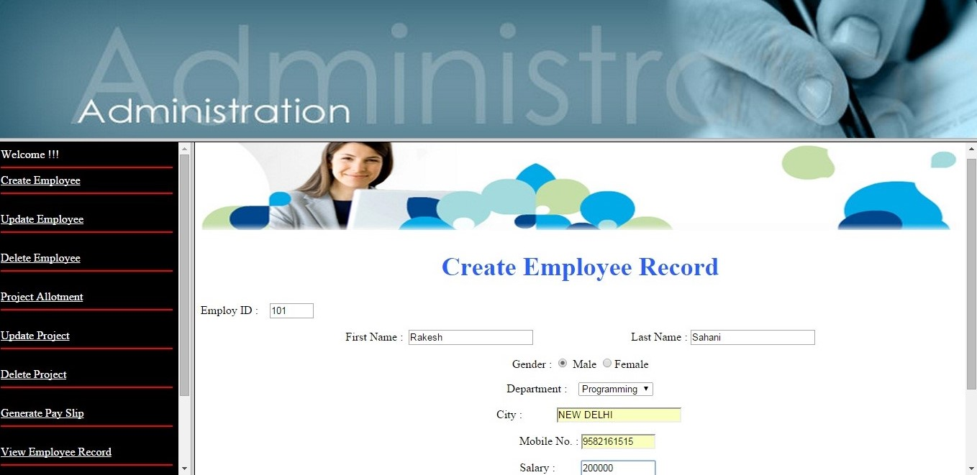**Create Employ page**

**Description**

This is the employ registration page in which admin can registered easily with the help of all fields like name, mobile, city etc.

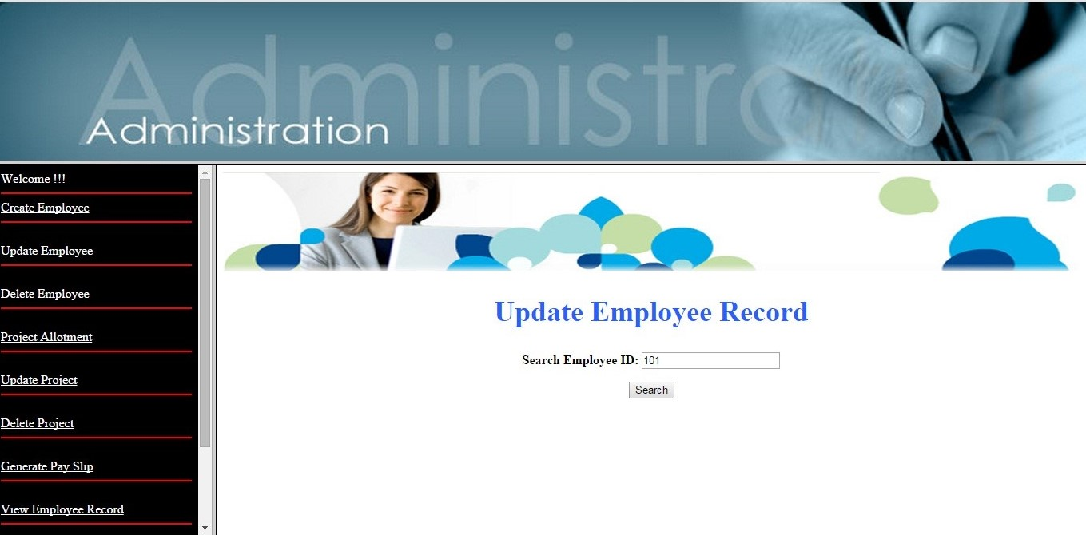

**Update Employ Record**

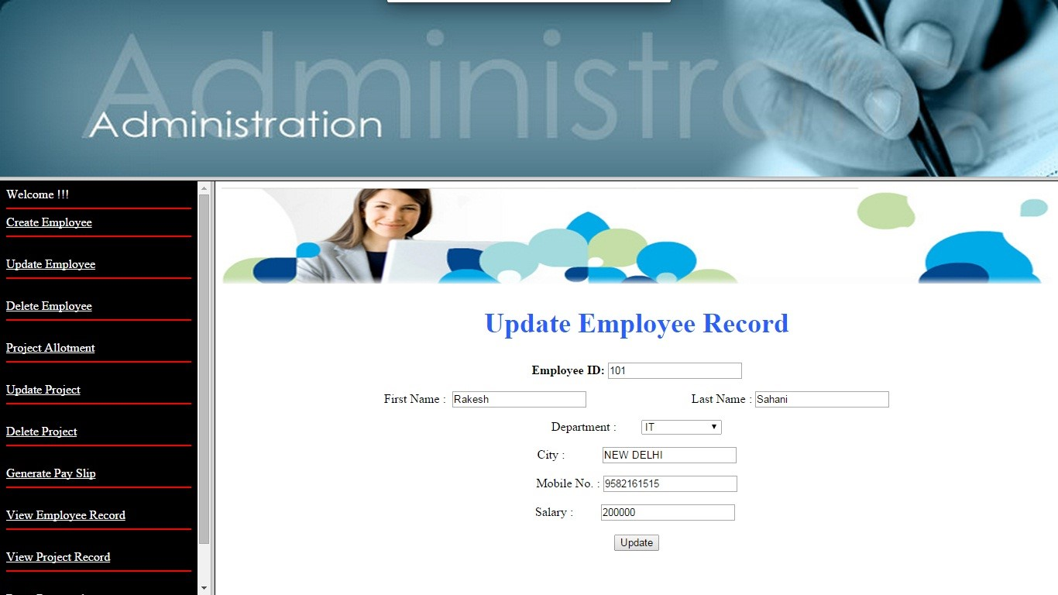

**Description**

In this page admin can update information of employee.

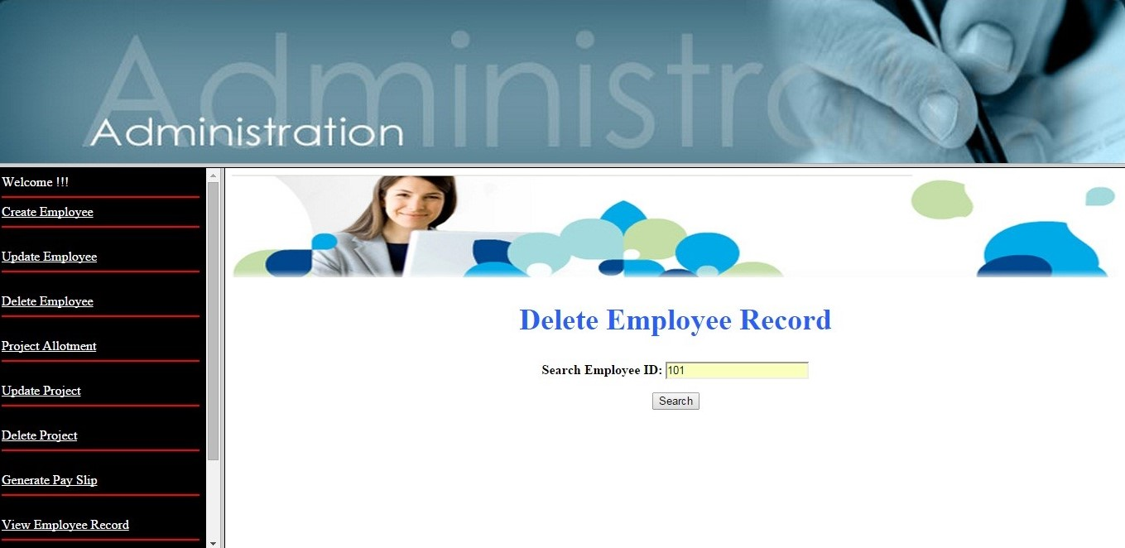**Delete Employee Record**

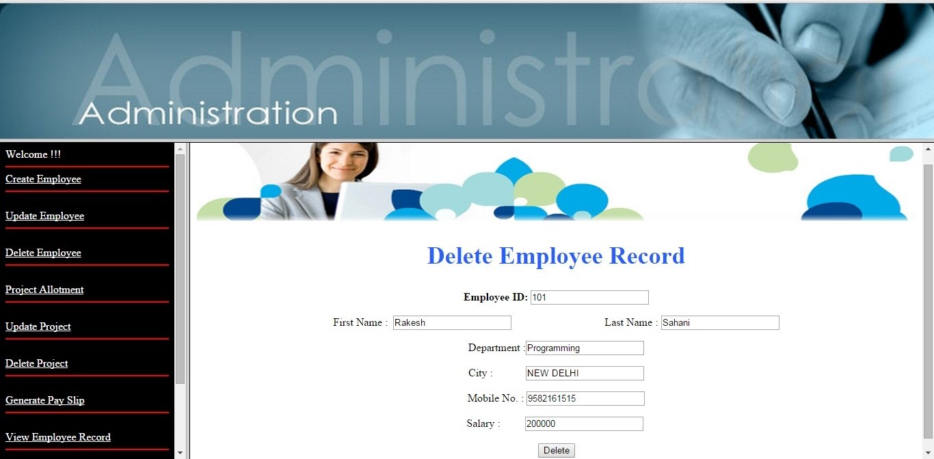

**Description**

In this page admin can delete the record of his employee in case employee leaves the firm.

**Project Allotment**

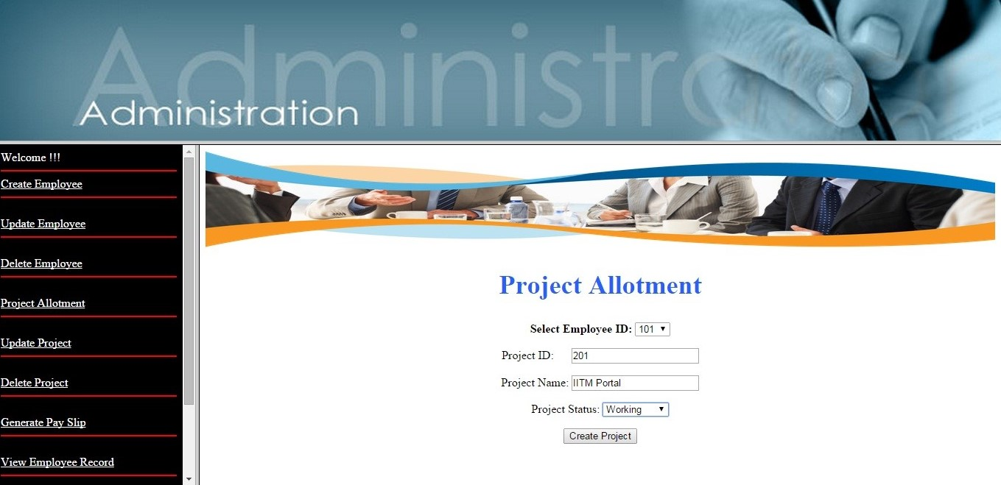

**Description**

In this page admin can assign the project of his employee in the firm.

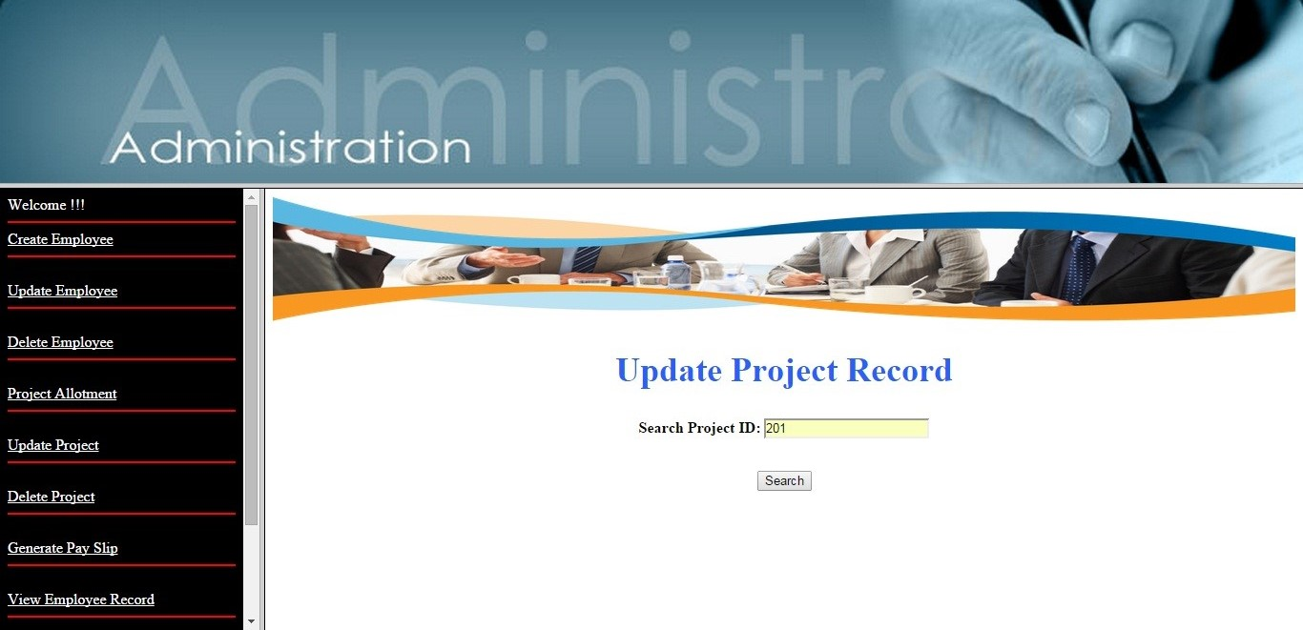**Update** **Project**

**Description**

In this page admin can update the assigned project of his employee in the firm.

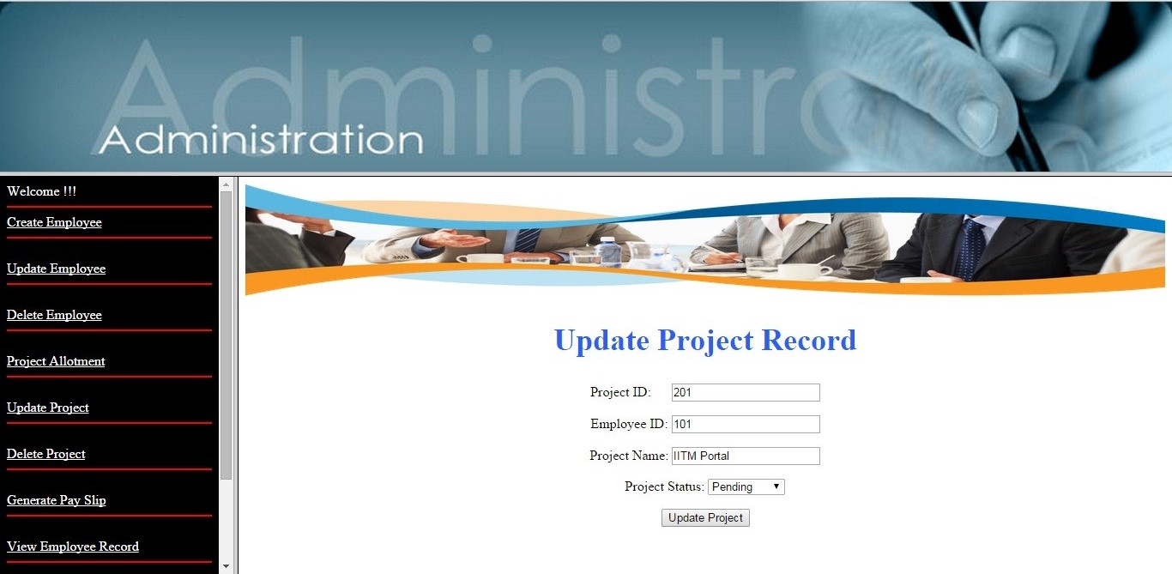**Description**

In this page admin can update the assigned project of his employee in the firm.

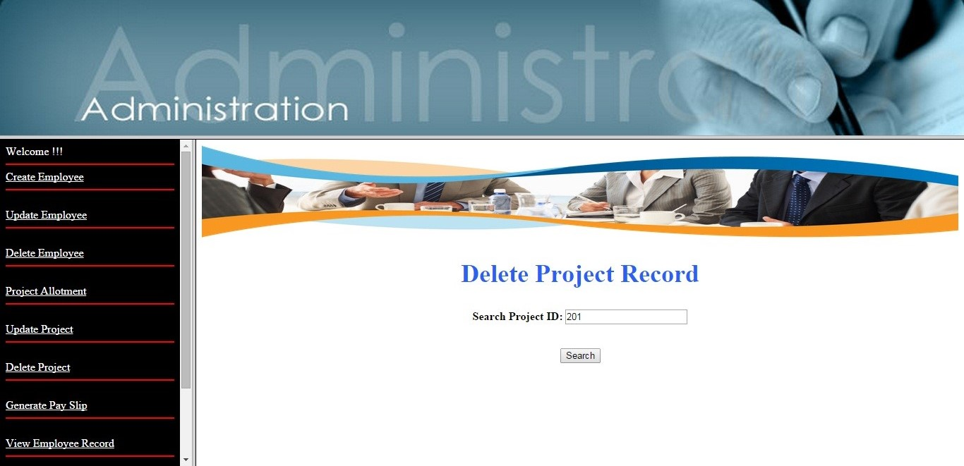**Delete Project**

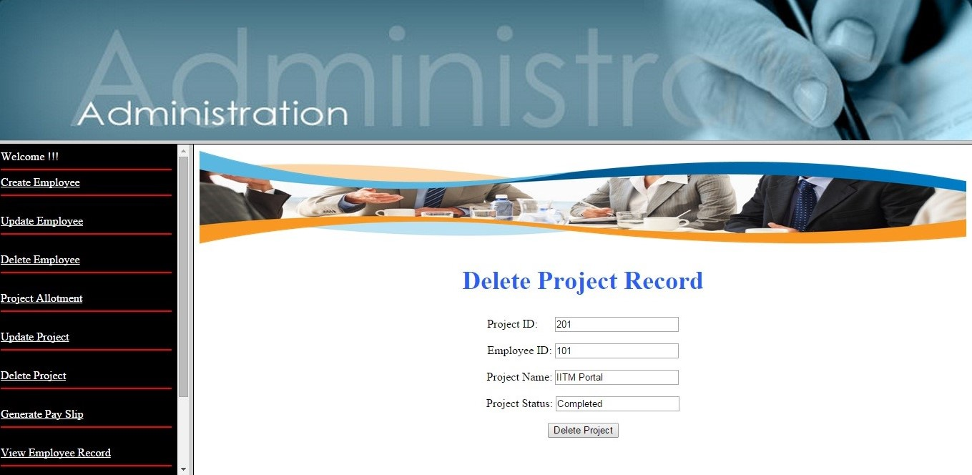**Description**

In this page admin can delete the record of project completed or drop the firm.

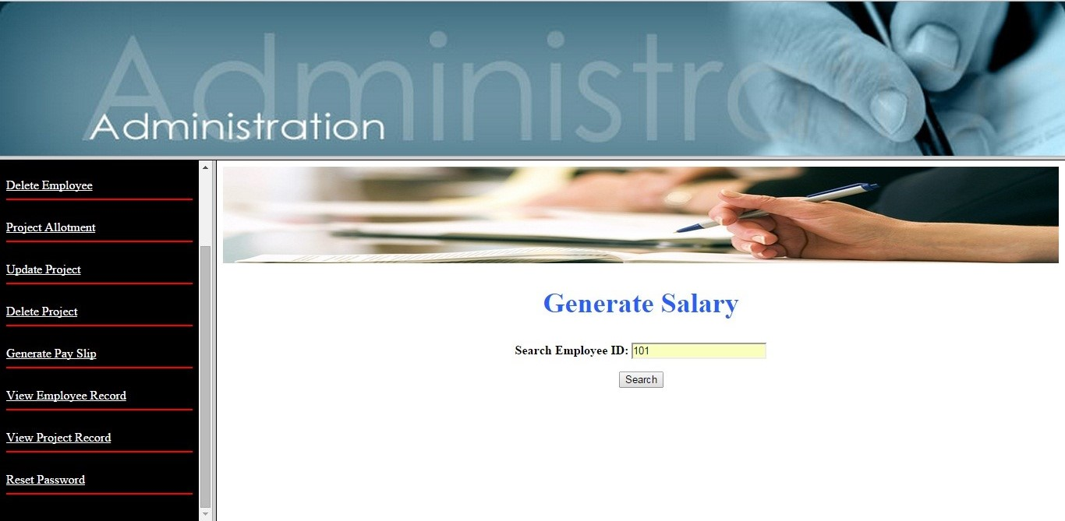**Generate PaySlip**

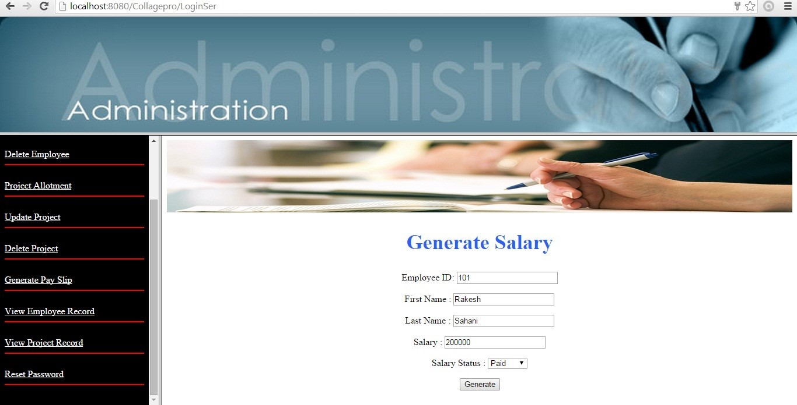**Description**

In this page admin can generate the salary of his employ.

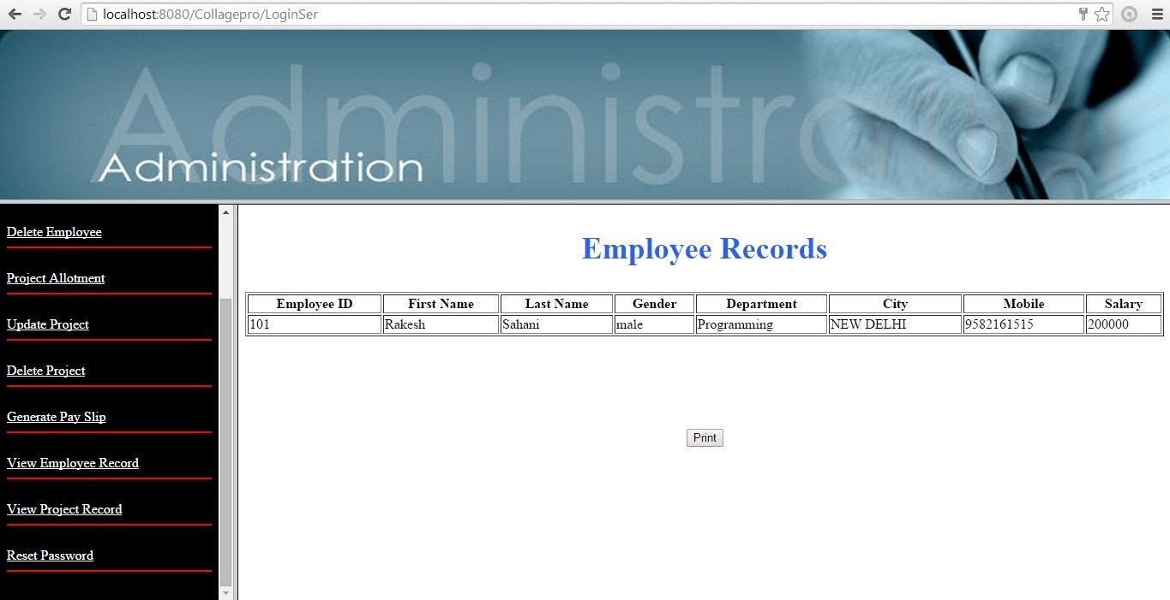**View Employ Record**

**Description**

In this page admin can view the record of his/her employee working in his/her firm.

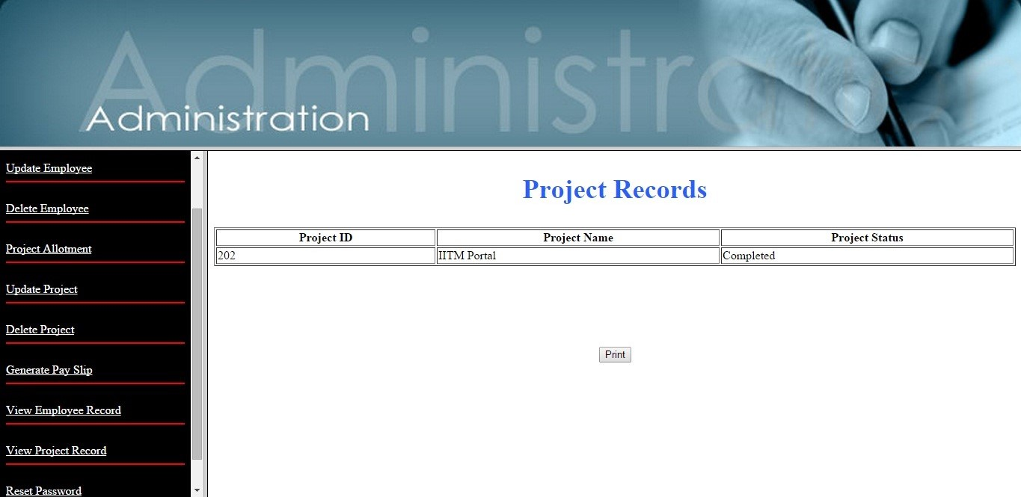**View Project Record**

**Description**

In this page admin can view the project record.

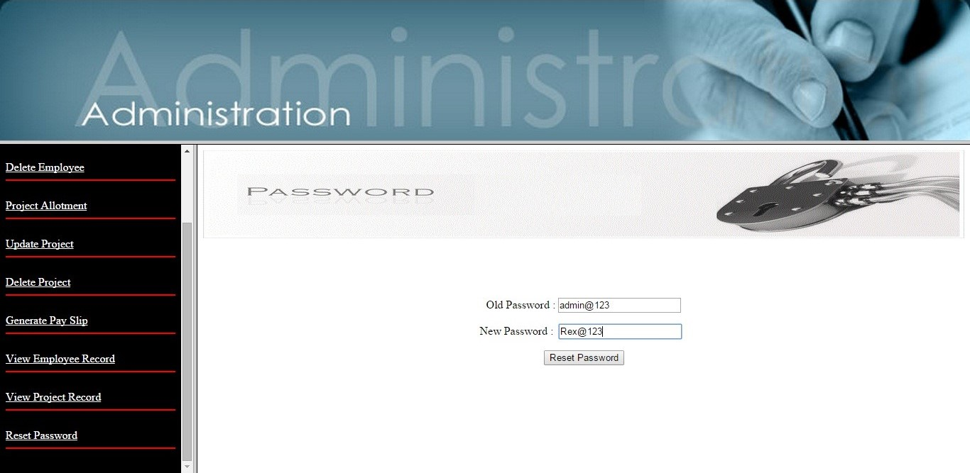**Change Password**

**Description**

In this page is meant for changing the current password in case admin want to change his password.

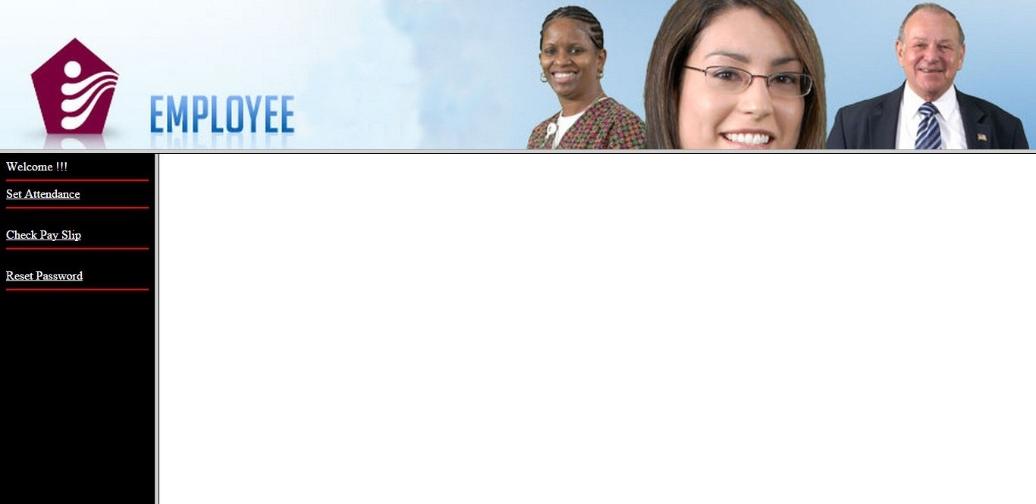**Employee**

**Description**

After login by employee, employee can select any option shown in the left hand side of a screen these options are as set attendance, check for pay slip and reset password.

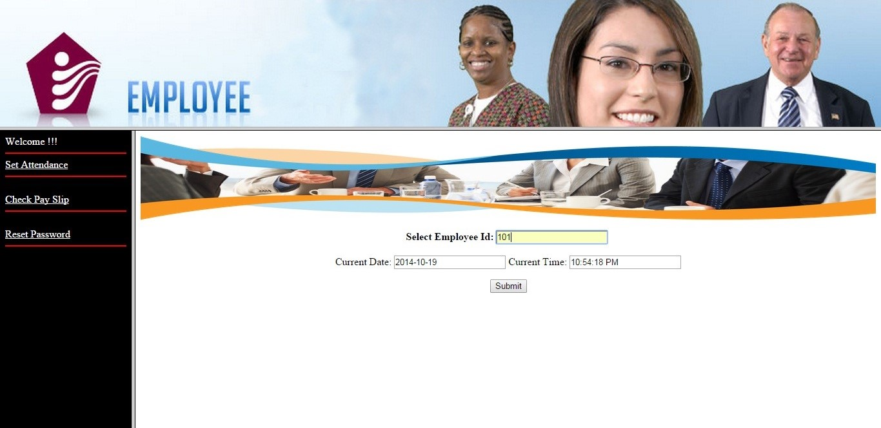**Set Attendance**

**Description**

In this page employee can set his attendance.

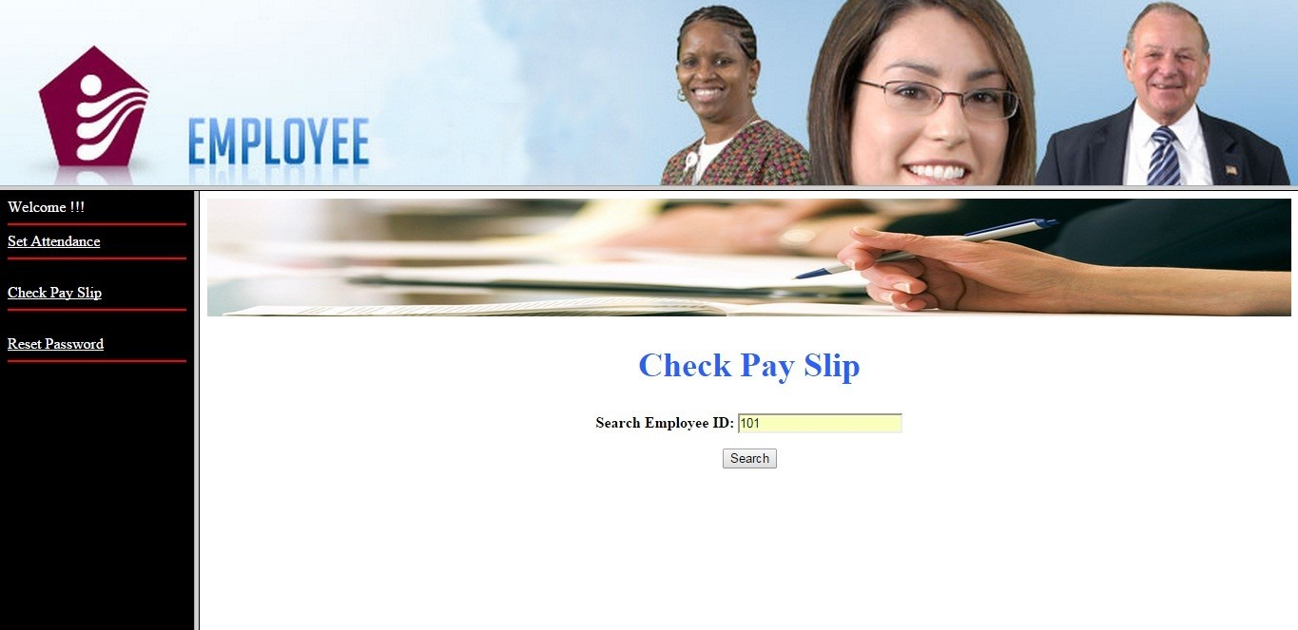**Check Payslip**

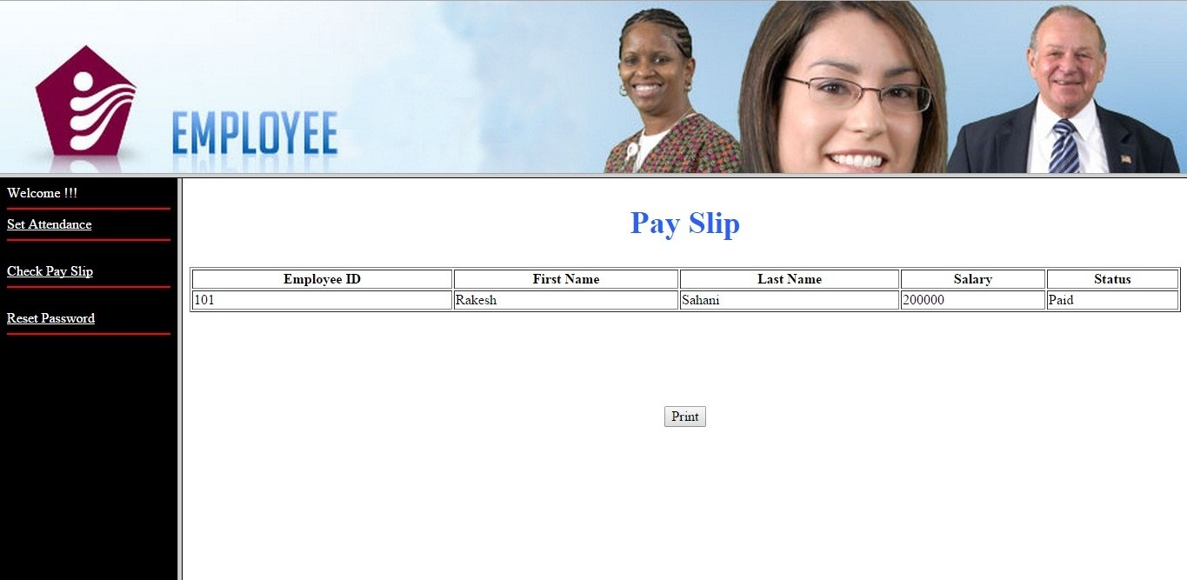

**Description**

In this page employee can check the payslip.

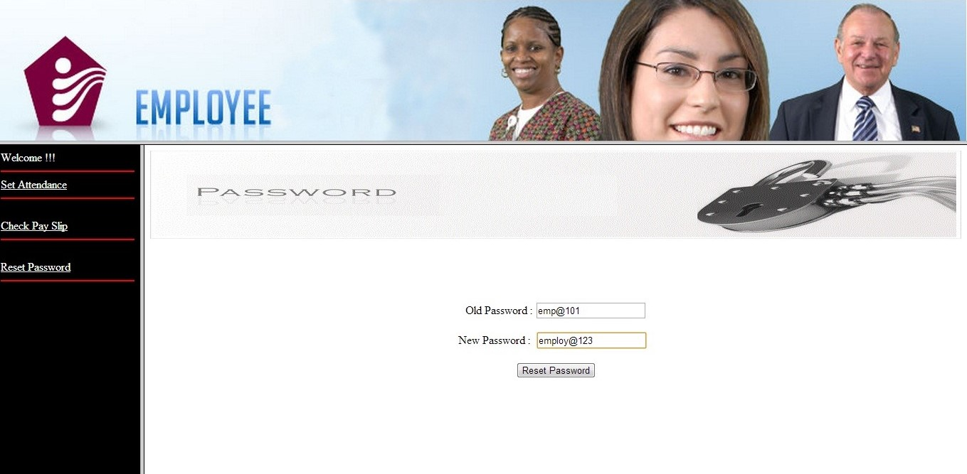**Change Password**

**Description**

In this page is meant for changing the current password in case admin want to change his password.

**Output Design**

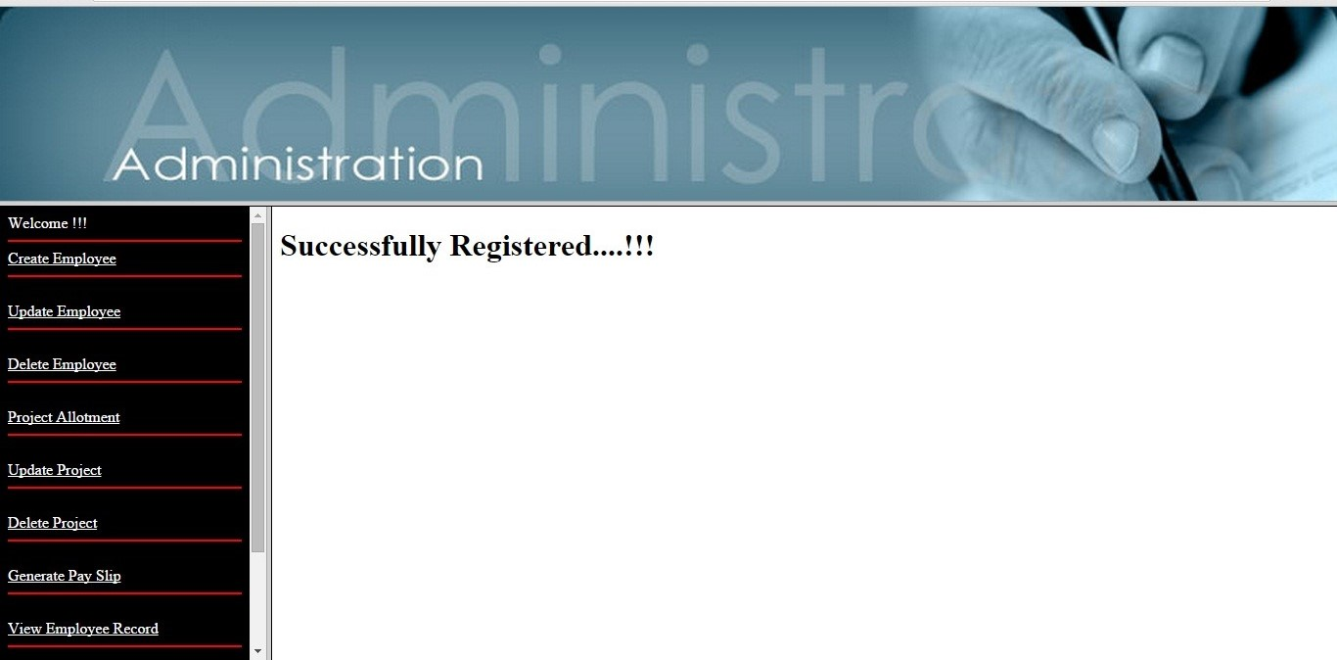**Employ Registered**

**Employ Updated**

**Employ Deleted**

**Project Registered**

**Project Updated**

**Project Deleted**

**Salary Generated**

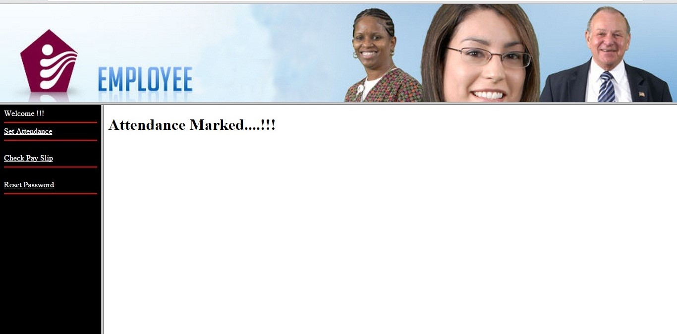**Attendance Marked**